Topic: TryHackMe: What is Networking?

Lab Overview
Platform: TryHackMe
Room: What is Networking?
Status: Completed

Objective
The objective of this room was to understand the basic concepts of computer networking and how different devices communicate with each other.

What I Learned
In this room, I learned the basic concepts behind computer networks and the Internet. I also learned about IP addresses, MAC addresses, IPv4, IPv6, and ICMP.
The room also included practical activities where I used basic networking concepts and commands to understand how devices can be identified and how connectivity can be checked.
This was useful for building my networking foundation because networking is an important part of cybersecurity and SOC analysis.

2. What Is Networking?
In this section, I learned what networking actually means and how different devices communicate with each other.
Basically, when two or more devices are connected and can communicate or share information, they form a network. For example, computers, phones, printers, and servers can all be connected to a network.
While doing the room, I understood that networking is not just about connecting devices. It is also about how those devices communicate and exchange information.
This gave me a basic understanding of networking, which is important for cybersecurity because a SOC analyst often needs to look at network activity when investigating an alert.
The question asked:
“What is the key term for devices that are connected together?”
My answer was: Network
I answered “Network” because when multiple devices are connected together so they can communicate or share information, that group of connected devices is called a network.
For example, computers, phones, printers, and servers can be connected to the same network and communicate with each other.
This was one of the basic concepts of the room and helped me understand what networking actually means before moving on to more advanced concepts.
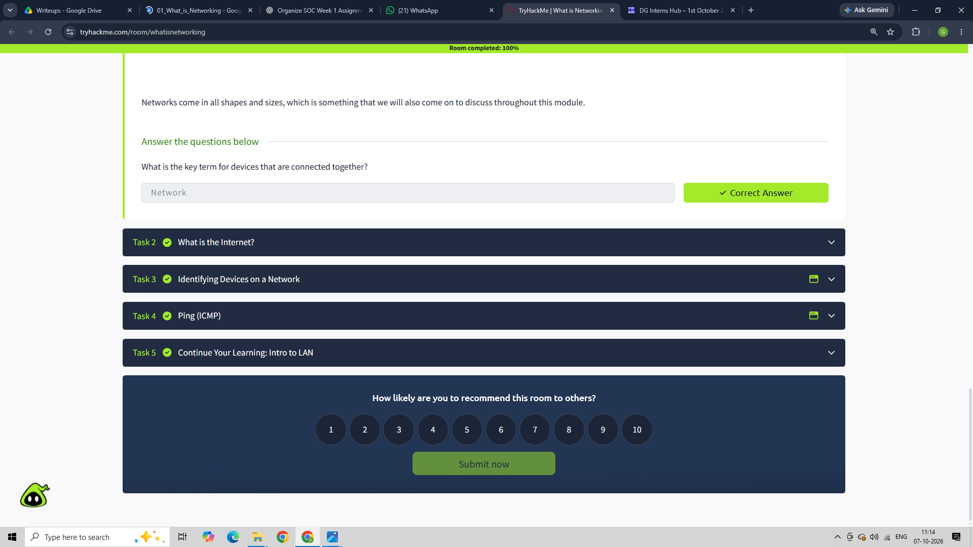

3. The Internet
In this section, I learned that the Internet is a large network made up of many smaller networks. I also learned that networks can be private or public, and devices use different labels to identify themselves on a network.
The room also explained the history of the Internet. I learned about ARPANET, which was an early network project, and how the World Wide Web (WWW) later made it possible to use the Internet for storing and sharing information.
The question asked:
“Who invented the World Wide Web?”
My answer was: Tim Berners-Lee
Why:
I answered Tim Berners-Lee because the room explained that he invented the World Wide Web in 1989. This helped me understand the difference between the Internet and the World Wide Web.
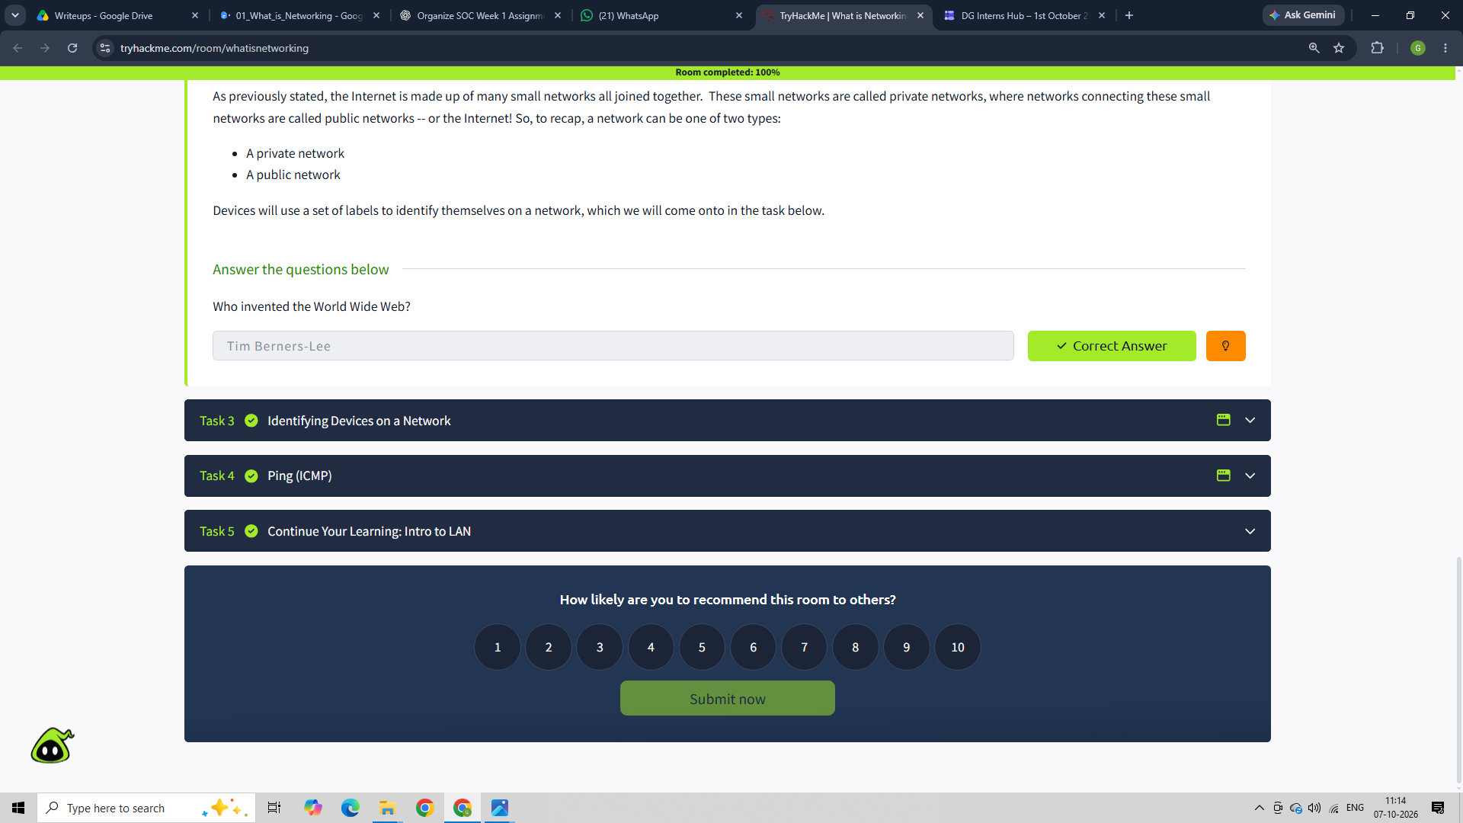

4. Identifying Devices on a Network
In this section, I learned how devices on a network are identified. I learned that devices mainly use two types of identification: an IP address and a MAC address.
I also learned the difference between public and private IP addresses, and that there are two main versions of IP addressing: IPv4 and IPv6. I also learned that a MAC address is a unique address associated with a device's network interface and that MAC addresses can be spoofed.
The practical part was interesting because I had to change Bob's MAC address to match Alice's in the interactive hotel Wi-Fi lab. This helped me understand how MAC spoofing can affect a basic network access control setup.

Questions and Answers
Question:
“What does the term ‘IP’ stand for?”
My answer: Internet Protocol
Why:
I answered this because IP stands for Internet Protocol, which is used for addressing and communication between devices on a network.

Question:
“What is each section of an IP address called?”
My answer: Octet
Why:
I learned that an IPv4 address is divided into four sections, and each section is called an octet.

Question:
“How many sections (in digits) does an IPv4 address have?”
My answer: 4
Why:
An IPv4 address is divided into four octets, such as 192.168.1.77.

Question:
“What does the term ‘MAC’ stand for?”
My answer: Media Access Control
Why:
MAC stands for Media Access Control. It is the unique address associated with a device's network interface.

Question:
“Deploy the interactive lab and spoof your MAC address to access the site. What is the flag?”
My answer: [THM{YOU_GOT_ON_TRYHACKME}]
Why:
I changed Bob's MAC address to match Alice's MAC address in the interactive lab. After the MAC address was spoofed, Bob was able to access the site, and the lab provided the flag as confirmation that the task was completed.
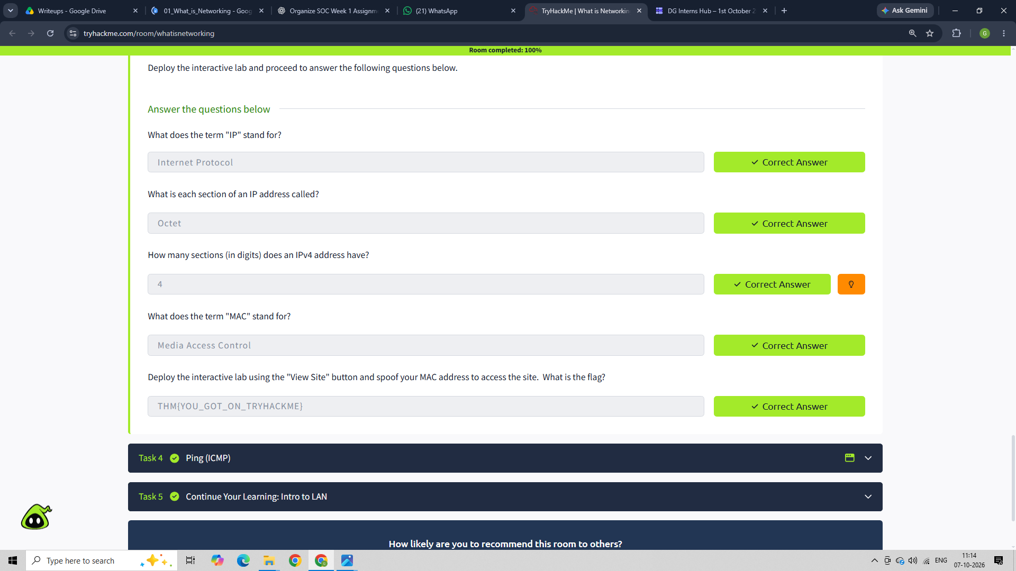

5. Ping (ICMP)
In this section, I learned about Ping, which is a basic network tool used to check whether a connection between devices exists and how well the connection is working.
I learned that Ping uses ICMP (Internet Control Message Protocol) packets. It sends an ICMP echo request to the target device and waits for an echo reply. The time taken for the response also helps measure the connection.
I also learned the basic syntax used to run Ping and then used the practical lab to ping 8.8.8.8.

Questions and Answers
Question:
“What protocol does ping use?”
My answer: ICMP
Why:
I answered ICMP because Ping uses Internet Control Message Protocol packets to check the connection between devices.

Question:
“What is the syntax to ping 10.10.10.10?”
My answer: ping 10.10.10.10
Why:
The basic Ping command uses ping followed by the IP address or website URL that we want to test. So for 10.10.10.10, the command is ping 10.10.10.10.

Question:
“What flag do you get when you ping 8.8.8.8?”
My answer: [THM{I_PINGED_THE_SERVER}]
Why:
I used the practical lab to ping 8.8.8.8. After successfully pinging the correct
address, the lab displayed a flag, which confirmed that I completed the practical part.
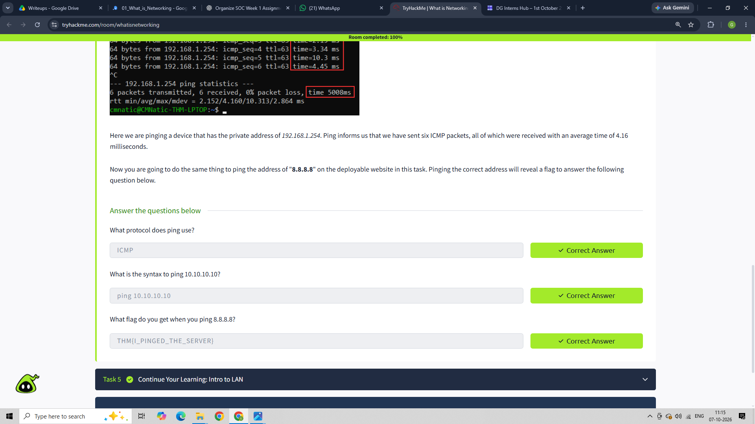

6. Conclusion
Overall, this room helped me build a basic understanding of networking. I learned how devices communicate, how the Internet connects different networks, and how devices can be identified using IP and MAC addresses.
I also got practical experience with MAC address spoofing and Ping, which helped me understand the concepts better instead of only reading about them.
This room gave me a good networking foundation that will be useful while learning cybersecurity and working with network-related security alerts.

